Carrier Sense Multiple Access (CSMA) - Part 2

**CSMA/CD**

1. If two stations sense the channel to be idle and begin transmitting simultaneously, they will both detect the collision almost immediately.
2. Rather than finish transmitting their frames, which are irretrievably garbled anyway, they should abruptly stop transmitting as soon as the cfollision is detected.
3. Quickly terminating damaged frames saves time and bandwidth.
4. This protocol, known as CSMA/CD is widely used on LANs in the MAC sublayer.
5. Access method used by ethernet: CSMA/CD

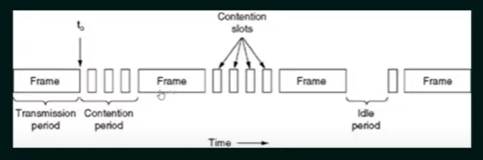

1. At the point marked t0, a station has finished transmitting its frame. Any other stat,on having a frame to send may now attempt to do so. Of two or more stations decide to transmit simultaneously, there will be a collision
2. Collisions can be detected by looking at the power or pulse width of the received signal and comparing it to the transmitted signal. (Transmitted signal is bigger than received normally)
3. After a station detects a collision, it aborts its transmission, waits a random period of time, and then tries again, assuming that no other station has started transmitting in the meantime.
4. Therefore, the model for CSMA/CD will consist of alternating contention and transmission periods, with idle periods occurring when all stations are quiet.

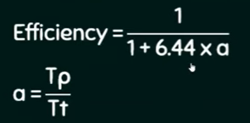

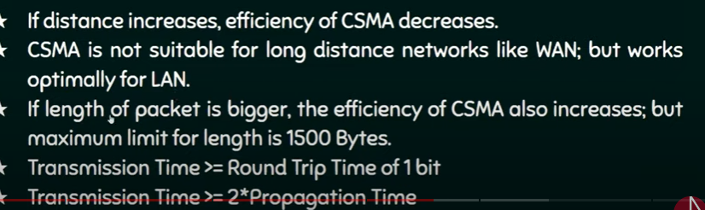

**CSMA/CA**

1. Exclusively for wireless
2. Is a network multiple access method in which acarrier sensing is used, but nodes attempt to avoid collisions by beginning transmission only after the channel is sensed to be idle
3. It is particularly important for wireless networks, where the collision detection of the alternative CSMA/CD is not possible due to wireless transmitters desensing their receivers during packet transmission.
4. CSMA/CA is unreliable due to the hidden node problem and exposed terminal problem. (Solution: RTS/CTS exchange – later)

Homework:

Find the correct box:

